Your Video Meeting
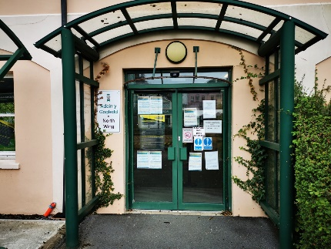 | Come to the front door of North Wing County Hall.
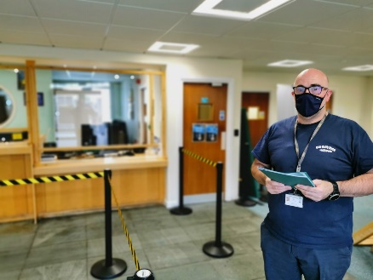 | The person on the door will say hello.
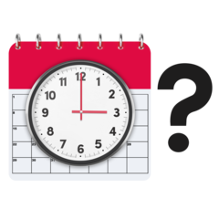 | They will check that you have a meeting booked.
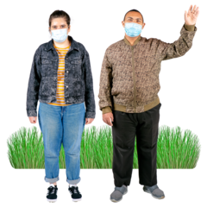 | You will be asked to wait outside if you are early for your meeting.
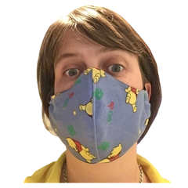 | You will be asked to wear a mask unless you don’t have to for medical reasons.
You will be asked if you are feeling well.

Please don’t come to the meeting if you any symptoms.
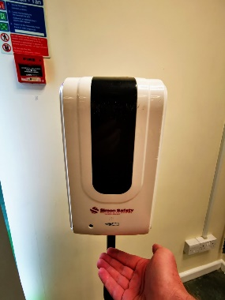 | You will be asked to sanitise your hands.
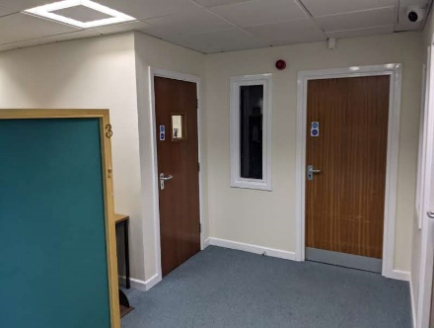 | At the time of your meeting you will be taken to the meeting room
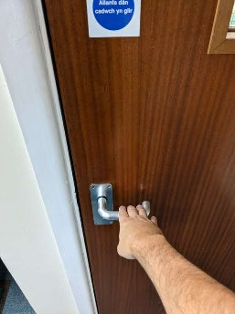 | You will be shown to the door and asked to enter the room.
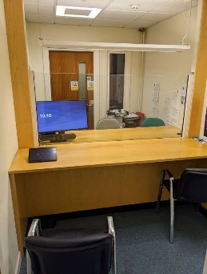 | When you enter the room it looks like this.
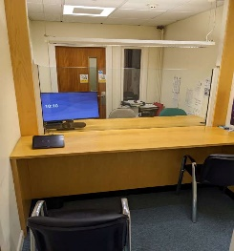 | Please take the left hand seat
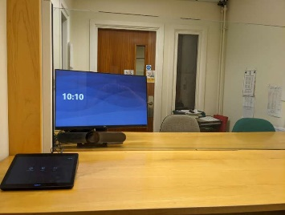 | You will be sat in front of a big screen
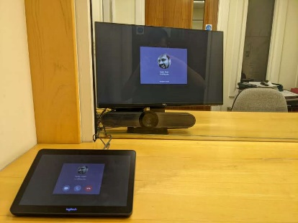 | The screen will change when your call is ready to be taken.
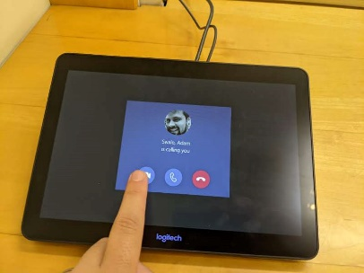 | This pad will be on the desk. This is where you will accept your call.
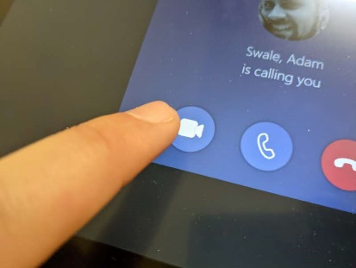 | Press here to start your call.
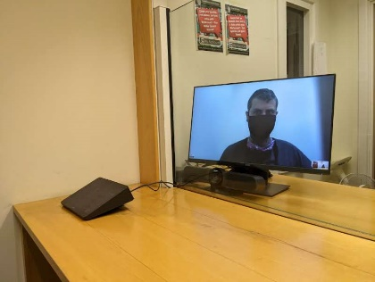 | The person you are meeting will appear on the large screen
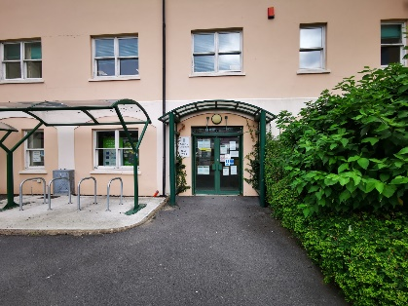 | When your meeting is finished leave the room. Then leave the building.

