- The full eligibility information and documents required for making an application to the Decarbonisation and Covid Challenge Fund are available through Sell2Wales. It is very important that you register directly in the opportunity, as Sell2Wales will also be used during the application window to send any updates and clarifications that may need to be considered in your application.
- Go to the sell2wales page: https://www.sell2wales.gov.wales/search/show/search_view.aspx?ID=SEP373101
- The page will show a summary of the opportunity. Click “Record your interest now” to access the documents, as well as make sure that you receive any updates about the fund as they are published.
- If you already have a Sell2Wales account, it will ask you to log in. If you don’t already have an account, you will need to create a new one. Instructions for opening an account are available here: https://www.sell2wales.gov.wales/helpandresources/4/suppliersocuserguide
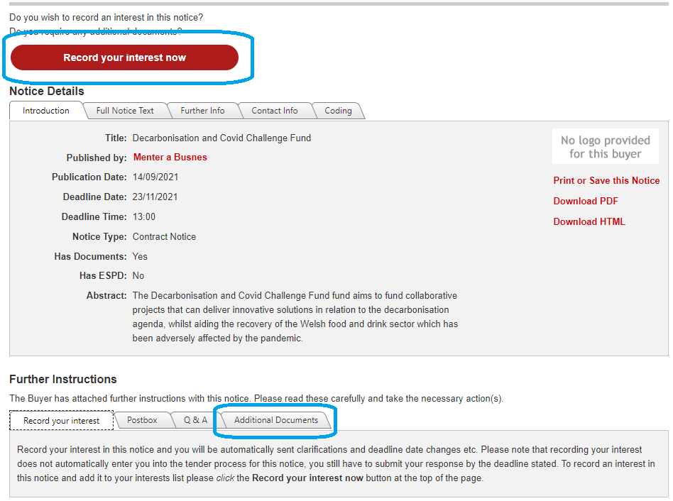

- Once you have successfully logged in and recorded your interest in the opportunity, you will be able to download the full application pack. This is found under the “Further Instructions” heading, within the “Additional Documents” tab.
If you require further technical support with the sell2wales website, there is a helpline that you can call on 0800 222 9004. Please note that the helpline will not be able to answer questions specifically in relation to the Challenge Fund, only how to access it.

